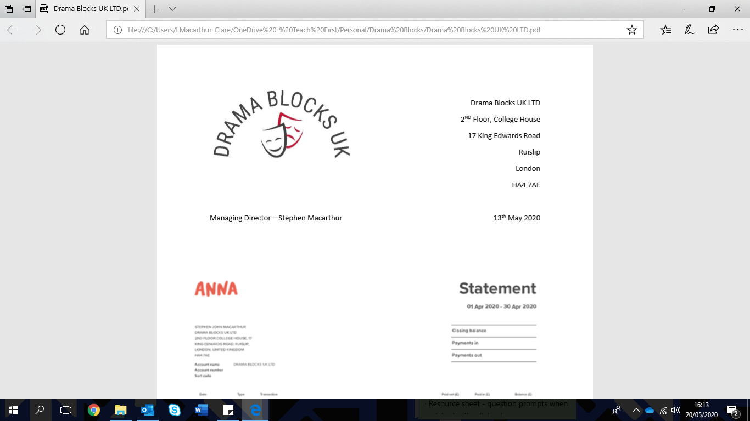

Price List

|  |  |  |  |  |
| --- | --- | --- | --- | --- |
| **Blocks** | **Black, grey, red or white painted finish** | | **Raw MDF** | |
| **Sizes (Dimensions in mm)** | **1-6 Blocks** | **7-12 Blocks** | **1-6 Blocks** | **7-12 Blocks** |
| 400L x 400W x 400H | £69.00 | £59.00 | £57.00 | £47.00 |
| 400L x 400W x 800H  (Tall podium) | £75.00 | £65.00 | £64.00 | £54.00 |
| 400L x 800W x 400H  (low, wide ‘bench’) | £73.00 | £63.00 | £62.00 | £52.00 |
| 500L x 500W x 200H | £68.00 | £58.00 | £56.00 | £46.00 |
| 500L x 500W x 500H | £82.00 | £72.00 | £70.00 | £60.00 |
| 1000L x 500W x 500H | £91.00 | £81.00 | £78.00 | £68.00 |
| 750L x 750W x 200H | £79.00 | £69.00 | £67.00 | £57.00 |
| 750L x 750W x 400H | £88.00 | £75.00 | £76.00 | £66.00 |
| 1000L x 1000W x 200H | £99.00 | £89.00 | £87.00 | £77.00 |
| 1000L x 1000W x 400H | £102.00 | £92.00 | £90.00 | £80.00 |
| 1000L x 1000W x 500H | £110.00 | £100.00 | £98.00 | £88.00 |
| **Hinged Blocks** | | | | |
| 500L x 500W x 500H | £117 | £107 | £102 | £92 |
| **Steps** | | | | |
| 2 step 500L x 500W x 500H | £82.00 | £72.00 | £69.00 | £59.00 |
| 2 step 1000L x 500W x 500H | £104.00 | £94.00 | £92.00 | £82.00 |
| 3 step 1000L x 700W x 700H | £132.00 | £122.00 | £119.00 | £109.00 |
| 4 step 1000L x1000W x 1000H | £170.00 | £160.00 | £157.00 | £147.00 |

*Drama Blocks UK is VAT registered and VAT will be added to all products at the current rate*

**Delivery charge will be quoted based on delivery address and amount ordered and can be found on your original quote.**

**Blocks are shipped pre-built with no assembly required.**

**Blocks are made in 18mm MDF and have an open base as standard – this means that blocks only have one weight bearing surface. If you require a base, please specify before ordering.**

**Lead times are subject to order size and location, and this will be agreed when order is placed.**

**Please ensure you carry out your own risk assessment before using any products.**

**Please note we do not accept cheques as a form of payment.**

Order Form

Please fill in this form and email it back to [sales@dramablocks.co.uk](mailto:sales@dramablocks.co.uk)

***We will only process your order once we have received full payment. We will only confirm the delivery date once the order has been processed.***

|  |  |
| --- | --- |
| Your Invoice Address: | Your Delivery Address: |
|  |  |
| Your Order Number |  |
| Your Contact name |  |
| Your contact telephone number |  |
| Finance office contact name |  |
| Finance office email address |  |

|  |  |  |  |
| --- | --- | --- | --- |
| **Item and Size** | **Colour** | **Amount** | **Total Cost** |
| *E.G - 500x500x500 block* | *Grey* | *4* | *£308* |
|  |  |  |  |
|  |  |  |  |
|  |  |  |  |
|  |  |  |  |
|  |  |  |  |
|  |  |  |  |
|  |  |  |  |
|  |  |  |  |

|  |  |
| --- | --- |
| Delivery Charge *Please refer to original quote* | £ |
| **Total Amount:** | £ |

*Drama Blocks UK is VAT registered and VAT will be added to all products at the current rate*

**Delivery charge will be quoted based on delivery address and amount ordered and can be found on your original quote.**

**Blocks are shipped pre-built with no assembly required.**

**Blocks are made in 18mm MDF and have an open base as standard – this means that blocks only have one weight bearing surface. If you require a base, please specify before ordering.**

**Lead times are subject to order size and location, and this will be agreed when order is placed.**

**Please ensure you carry out your own risk assessment before using any products.**

**Please note we do not accept cheques as a form of payment.**